***DataStor Company***

"Another rejected shipment!" exclaimed Bill Roberts. "That makes four in the past twenty days!" Tony Escalera knew that Roberts would not take the news well. Something was wrong, and things were going to be uncomfortable for everybody at DataStor until the problem was resolved.

DataStor produces magnetic data storage devices and media for the computer industry. A few years ago, they began producing the DataStor DS1000, a compact hard drive with the capability of storing l gigabyte (1,000 megabytes) of information. Most of the drives they produce are sold to companies that resell the drives under their own product label to consumers and commercial businesses. DataStor's main buyer is Four-D Office Products. Four-Dis a national retailer that sells the drives under its own product label to final consumers and some computer companies. This arrangement with Four-D has been very profitable for DataStor.

Bill Roberts has been vice-president in charge of sales at DataStor for the past four years. His rapid rise up the company's management ladder was due in large part to his role in developing the partnership with Four-D Office Products. Four-D was impressed with Roberts and DataStor's commitment to quality.

In the DataStor DS1000 hard drive manufacturing process, each of the three 8-hour shifts produces approximately 120 drives per day. As part of the quality inspection process, one drive is sampled each hour and subjected to the PDQ (Performance and Drive Quality) test, originally developed by DataStor. The PDQ is a rigorous test of a hard drive that measures the performance of the drive in a variety of conditions, checks the accuracy and speed of the drive in storing and retrieving information, and tests for defects in the drive's mechanism and storage media. The PDQ is a relatively expensive test and takes up to twenty minutes to complete. At the conclusion of the test, an overall test score based on drive characteristics is computed. PDQ test scores for the hard drives produced at DataStor have historically followed a normal distribution with a mean value of 7.0 and a standard deviation of .30 when the process has been in control. Each hour, the new PDQ value is added to a control chart used in monitoring the process for early detection of drive quality problems. Signals from test scores below the lower control limit (LCL) may indicate a drop in quality, while signals from test scores above the upper control limit (UCL) may indicate a potential improvement in the process.

Shipments of DataStor DSlO00 hard drives are made to Four-D once each day. Before Four-D accepts a shipment, they subject a random sample of 10 drives to the PDQ test as a final inspection. At Four-D, a drive is judged to be nonconforming if its performance test score falls below 6.2. If one or more drives in the sample of 10 are found to be nonconforming, the entire shipment is judged to be "unacceptable" and returned to DataStor. Under the arrangement with Four-D, DataStor is required to pay a penalty to Four-D and must replace the unacceptable shipment within 24 hours. Further penalties are assessed for each additional day that passes before the shipment is replaced.

The production engineers at DataStor have told Bill Roberts that ‘zero­defect’ production is virtually impossible, but that the percentage of defects has been reduced to the point that only rarely will a shipment be judged unacceptable. In recent weeks, however, there has been a noticeable increase in the frequency of returned shipments from Four-D. Tony Escalera, the chief production engineer at DataStor, brought word of the latest returned shipment to Bill Roberts.

Roberts: "Another rejected shipment! That makes four in the past twenty days! What’s going on, Tony?"

Escalera: "At this point, I don't know any more than you do, Mr. Roberts. To borrow some statistical terminology, it's possible that we're just experiencing a few 'false rejections.' After all, there is variability in any process. Even if the actual quality levels are on target, we expect a few inspections to indicate otherwise."

Roberts: "The number of rejections still seems to be much higher than we have experienced in the past. Do you think that Four-D has become more demanding in their acceptable level of quality?"

Escalera: "That's possible, but surely they would have let us know first. Maybe they are making mistakes when they conduct the PDQ tests or when they interpret the results."

Roberts: "Or maybe we're the ones making the mistakes. Do we have evidence of any quality problems here?"

Escalera: "As you know, we sample one drive each hour of each shift and run the PDQ test. In the past, we plotted the individual test scores on a control chart to monitor the process for early warning signals of problems. Recently, though, we began plotting the average of the eight PDQ test values co1lected over each shift on our charts instead of the individual values. Our new quality control person told us that this approach should result in a more sensitive warning system."

Roberts: "Have your control charts indicated any problems?"

Escalera: "No. As you can tell from this latest two-sigma control chart, there have not been any out of control signals in the past 150 shifts. That's actually a surprising performance record. We would normally expect about seven or eight values out of 150 to fall outside the two-sigma control limits. If anything, it looks like the variability in process quality is much lower than it has been in the past."

Control Chart for Shift Average PDQ Test Scores

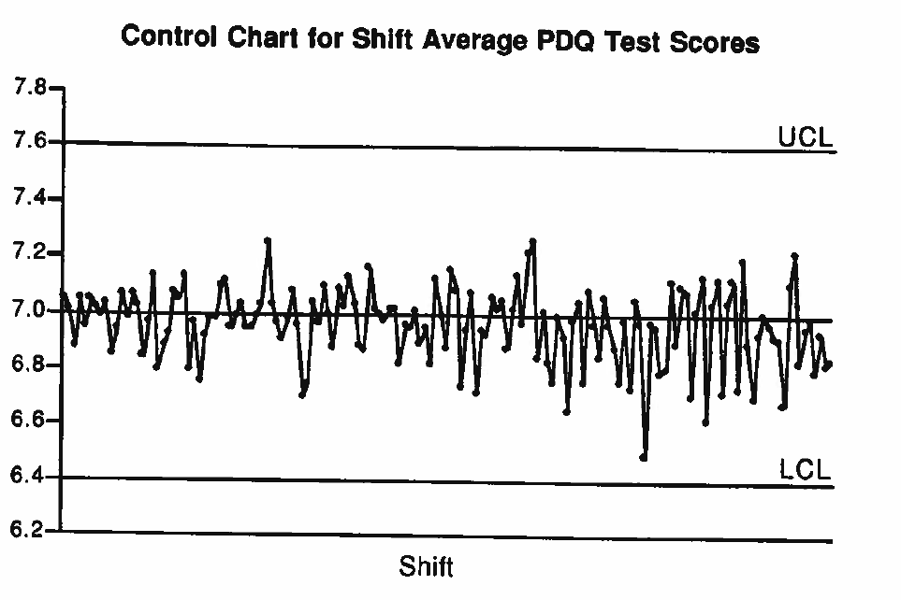

Roberts: "Yes, but if the variability has actually decreased, why haven't we seen fewer returned shipments? Are we plotting and interpreting these shift averages on the charts correctly?"

Escalera: "I think so. I'll go back and let the quality control person take a look at what we've been doing."

Roberts: "Maybe the problem really is at Four-D. Wait a minute! We're forgetting something. If everything looks good on our end, but Four-D is finding non-conformances in our shipments, could the problem be due to damage during shipment?"

Escalera: "Someone else suggested that possibility to me earlier. But it's pretty unlikely given the protective packaging we use."

Roberts: "Tony, we need to resolve this problem, if there is one, as quickly as possible. Check out our side first for the source of the problem. If you can't tum up anything here, make some inquiries with your contacts at Four-D."

## Assignment

The data from the drive quality tests conducted at DataStor over the past 150 shifts are contained in the file DATASTOR.DAT on the Data Disk. The Data Description section contains a description of this data file.

Using this data set and other information given in the case, help Bill Roberts and Tony Escalera solve the quality problem they are experiencing at DataStor. In particular, speculate as to the source of the problem based on your analysis of the data. The Case Questions will assist you in your analysis of the data. Use important details from your analysis to support your recommendation.

## Data Description

The data for the DataStor Company case is contained in the file DATASTOR.DAT on the Data Disk. The file contains performance testing data on the DataStor DS1000 hard drives produced over the past 150 shifts. A partial listing of the data is shown below.

|  |  |  |  |  |  |
| --- | --- | --- | --- | --- | --- |
| Week | Dal'. | Shift | Hours | Drives | Shift PDQ |
| 1 | 1 | 1 | 91.75 | 111 | 7.052 |
| 1 | 1 | 2 | 91.25 | 115 | 7.010 |
| 1 | 1 | 3 | 103.75 | 128 | 6.884 |
| 1 | 2 | 1 | 96.75 | 123 | 7.051 |
| 1 | 2 | 2 | 103.25 | 128 | 6.952 |
| 1 | 2 | 3 | 91.50 | 115 | 7.049 |

The variables are defined as follows:

|  |  |
| --- | --- |
| **Variable** | **Variable Description** |
| DAY: | Day of the week (l=Monday, 5=Friday). |
| HOURS: | Total number of hours worked by production employees during the shift. |
| WEEK: | Week (1-10) |
| SHIFT: | 1, if first shift; 2, if second shift; 3, if third shift. |
| DRIVES: | Number of DataStor OS1000 hard drives produced during the shift. |
| SHIFT PDQ: | The average PDQ test score recorded for the eight drives tested during the shift One randomly selected drive is tested each hour of every shift. |